Problem A

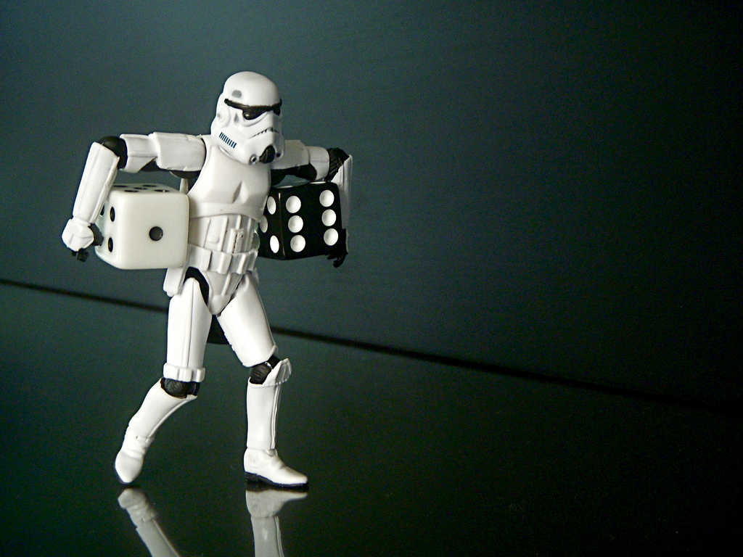

*Photo by*[*JD Hancock*](https://www.flickr.com/photos/jdhancock/3582171012)

Gunnar and Emma play a lot of board games at home, so they own many dice that are not normal 66-sided dice. For example they own a die that has 1010 sides with numbers 47,48,…,5647,48,…,56 on it.

There has been a big storm in Stockholm, so Gunnar and Emma have been stuck at home without electricity for a couple of hours. They have finished playing all the games they have, so they came up with a new one. Each player has 2 dice which he or she rolls. The player with a bigger sum wins. If both sums are the same, the game ends in a tie.

**Task**

Given the description of Gunnar’s and Emma’s dice, which player has higher chances of winning?

All of their dice have the following property: each die contains numbers a,a+1,…,ba,a+1,…,b, where aa and bb are the lowest and highest numbers respectively on the die. Each number appears exactly on one side, so the die has b−a+1b−a+1 sides.

**Input**

The first line contains four integers a1,b1,a2,b2a1,b1,a2,b2 that describe Gunnar’s dice. Die number ii contains numbers ai,ai+1,…,biai,ai+1,…,bi on its sides. You may assume that 1≤ai≤bi≤1001≤ai≤bi≤100. You can further assume that each die has at least four sides, so ai+3≤biai+3≤bi.

The second line contains the description of Emma’s dice in the same format.

**Output**

Output the name of the player that has higher probability of winning. Output “Tie” if both players have same probability of winning.

|  |  |
| --- | --- |
| **Sample Input 1** | **Sample Output 1** |
| 1 4 1 4  1 6 1 6 | Emma |

|  |  |
| --- | --- |
| **Sample Input 2** | **Sample Output 2** |
| 1 8 1 8  1 10 2 5 | Tie |

|  |  |
| --- | --- |
| **Sample Input 3** | **Sample Output 3** |
| 2 5 2 7  1 5 2 5 | Gunnar |